Quora

🎓 Definition
# Source: ScreenShots Source: Provided by: [Persons Table -> ID Column: 1, Name_En Column: Motasem Essam] -> Tool: [Lightshot Program] -> From [Site: https://ar.quora.com/] on [2/12/2026]
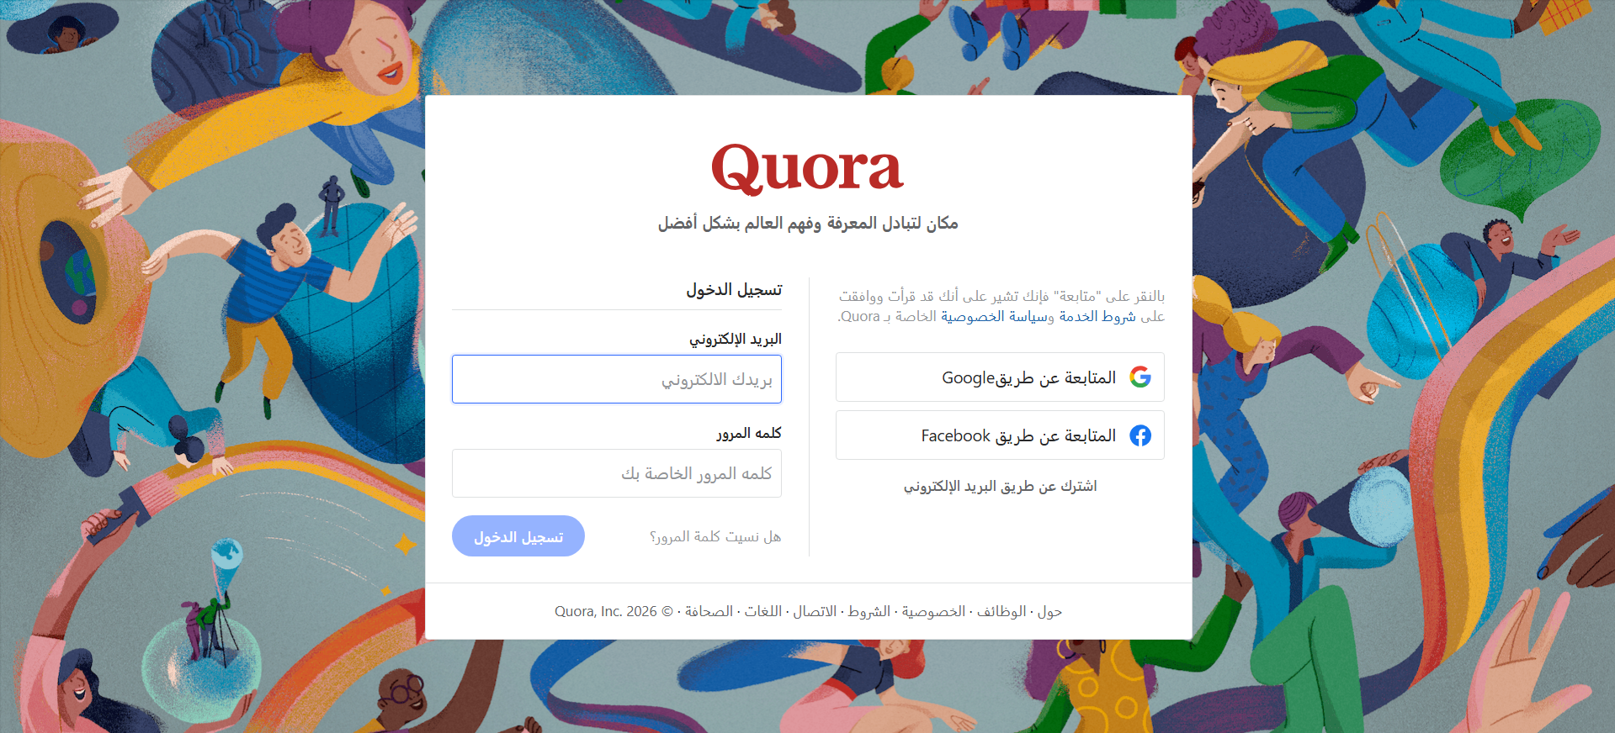
# Source: AI Source: Provided by: [Data Path: Persons Table -> ID Column: 1, Name_En Column: Motasem Essam] -> From: [ChatGPT] on [2/12/2026]
Quora is a popular question-and-answer (Q&A) platform where people can ask questions on any topic and get answers from the community, including experts, enthusiasts, or anyone with knowledge on the subject.
Here’s a clear breakdown:

Purpose
# Source: AI Source: Provided by: [Data Path: Persons Table -> ID Column: 1, Name_En Column: Motasem Essam] -> From: [ChatGPT] on [2/12/2026]
- To share and gain knowledge across countless topics — from science and technology to lifestyle, history, and personal advice.
- Users can ask questions, write answers, and upvote answers they find useful.

How It Works
# Source: AI Source: Provided by: [Data Path: Persons Table -> ID Column: 1, Name_En Column: Motasem Essam] -> From: [ChatGPT] on [2/12/2026]
- Ask a Question: Anyone can post a question.
- Answer a Question: Other users, sometimes experts or professionals, respond with detailed answers.
- Upvote/Downvote: Helps highlight the best answers.
- Follow Topics & People: Users can follow topics they’re interested in (e.g., “Artificial Intelligence” or “Cooking”) and people who provide good answers.

Content Style
# Source: AI Source: Provided by: [Data Path: Persons Table -> ID Column: 1, Name_En Column: Motasem Essam] -> From: [ChatGPT] on [2/12/2026]
- Answers are usually long-form and explanatory, unlike Twitter or Reddit’s brief comments.
- Answers often include personal experience, references, or examples.

History
# Source: AI Source: Provided by: [Data Path: Persons Table -> ID Column: 1, Name_En Column: Motasem Essam] -> From: [ChatGPT] on [2/12/2026]
- Founded in 2009 by Adam D’Angelo (former CTO of Facebook) and Charlie Cheever.
- Headquarters: Mountain View, California, USA.
- Over the years, it has grown into a major global knowledge-sharing community.

Other Features
# Source: AI Source: Provided by: [Data Path: Persons Table -> ID Column: 1, Name_En Column: Motasem Essam] -> From: [ChatGPT] on [2/12/2026]
- Spaces: Community hubs where people with similar interests can post and discuss.
- Quora+ (Paid Membership): Offers access to premium answers and content.

In Simple Terms
# Source: AI Source: Provided by: [Data Path: Persons Table -> ID Column: 1, Name_En Column: Motasem Essam] -> From: [ChatGPT] on [2/12/2026]
💡 In simple terms: Quora is like a giant online library of questions and answers, but anyone can contribute and interact.

